Landscape & Irrigation System Monthly Service Report

Client | Emrill – Nikki Beach Resort & Spa | Facilities Management | Emrill Services LLC
Location | Nikki Beach resort, Jumeirah | JOB CODE | 22A&B15101
Service Provided | Landscape & Irrigation Maintenance | Month | August 2026

ANNUAL PROACTIVE PLAN MAINTENANCE
Activities | Frequency | Jan. | Feb. | Mar. | April | May | June | July | Aug. | Sep. | Oct. | Nov. | Dec.
General cleaning/Removal of debris | Daily | ● | ● | ● | ● | ● | ● | ● | ● | ● | ● | ● | ●
Checking of water availability | Daily | ● | ● | ● | ● | ● | ● | ● | ● | ● | ● | ●
Hand-watering of Pots | Daily | ● | ● | ● | ● | ● | ● | ● | ● | ● | ● | ●
Lawn Moving / Edge Cutting | Weekly | ● | ● | ● | ● | ● | ● | ● | ● | ● | ● | ● | ●
Pruning Shrubs & Hedges | Monthly | ● | ● | ● | ● | ● | ● | ● | ● | ● | ● | ● | ●
Pruning Groundcovers | Monthly | ● | ● | ● | ● | ● | ● | ● | ● | ● | ● | ● | ●
Weeding | Monthly | ● | ● | ● | ● | ● | ● | ● | ● | ● | ● | ● | ●
Soil Cultivation | Monthly | ● | ● | ● | ● | ● | ● | ● | ● | ● | ● | ● | ●
Trees (Crown Thinning, cleaning) | Bi-Monthly | ● |  | ● |  | ● |  | ● |  | ● |  | ●
Lawn Aeration, Vert cutting | Half Yearly |  |  |  |  |  | ● |  |  |  |  |  | ●
Replacement of Seasonal Flowers | Quarterly |  |  | ● |  |  | ● |  |  |  | ●
Fertilization | Quarterly |  | ● |  |  | ● |  |  |  | ● |  | ●
Palm Trees Services | Quarterly |  | ● |  | ● |  |  |  | ● |  |  |  | ●
Agriculture Pest Control | Half Yearly |  |  |  | ● |  |  |  |  | ●
Trees (Crown Reduction) Hard-Pruning | Annual |  |  |  |  |  |  |  |  |  |  |  | ●

OPERATIONS PERFORMANCE
PPM TASKS Carried-out during the Month:
Activity | Frequency | Complete (✓) | Pending (✗) | Remarks
Checking of water availability | Daily | ✓ |  | Everyday
Hand-watering of Pots | Daily | ✓ |  | Everyday
Lawn Moving / Edge Cutting | Weekly | ✓ |  | Every Monday
Pruning Shrubs & Hedges | Monthly | ✓
Pruning Groundcovers | Monthly | ✓
Weeding | Monthly | ✓
Soil Cultivation | Monthly | ✓
Palm Trees Services | Quarterly | ✓ |  | Trunk Cleaning for Coconut trees is completed.  Washingtonia dry fronds removal scheduled to start from 07.09.2026

Irrigation Water Meter Consumption Log

Month | January 2026 | Feb 2026 | March 2026 | April 2026 | May 2026 | June 2026 | July 2026 | August 2026 | Sept 2026 | Oct 2026 | Nov 2026 | Dec 2026
Total Monthly Consumption (m3) | 3743.14 m3 | 4078.94 m3 | 2995.75 m3 | 3847.85 m3 | 6328.38 m3 | 6603.85  m3 | 6868.52  m3 | 6666.19 m3

EXTRA OR PENDING TASKS Carried-out during the Month:
S/N | Description
01 | Application of Disper Complex (Micronutrient Mixture) Fertilizer for Coconut Palm trees.
02 | Application of Humic Acid (POW Humus) to support root development and enhance nutrient uptake of Ficus panda.
03 | Application of Aqua Lock (Anti Tran spirant spray) for Ficus panda to reduce moisture loss & minimize transpiration stress.
04 | Application of Organic Compost (Cow Manure) in Coconut Palm trees to enhance organic matter content, and support overall soil fertility.
05 | Application of Ammonium Sulphate Fertilizer (N-20.5%; S-23%) to promote foliage growth and enhance plant vigor of Sesuvium in the beach area.
06 | Application of Desert Energy NPK Fertilizer (12-12-17 + 2MgO + TE) for Coconut Plam trees in Beach Area.
07 | Application of Pesticides highly effective against Thrips, Grubs and Mites (Emamectin Benzoate 5%WDG) for Washingtonia, Date palm & Coconut Palm trees.
08 | Application of Pesticides highly effective against Cockroach (Cypermethrin 25% EC) for Ipomea and Pandanus.
09 | Application of Pesticides broad Spectrum insecticide (Abamectin 1.8 EC) across the landscape areas.
10 | Application of Desert Energy (NPK Water Soluble Fertilizer) for Indoor plants

REACTIVE MAINTENANCE TASKS Carried-out during the Month:
S/N | Description
01 | Application of Desert Energy NPK Fertilizer (12-12-17 + 2MgO + TE) for Leucophyllum Hedges in front Villa and near swimming Pool area.
02 | Application of Pesticides highly effective against Aphids & Cycad butterflies (Lambda- cyhalothrin 5% EC) for Cycas.
03 | Application of Peat Moss in front of Villas to enhance organic matter content, and support overall soil fertility
04 | Replanting of Saplings into Nursery Pots for temporary establishment prior to transplantation into the landscape areas under suitable temperature conditions.
05 | Submission of an Observation Master sheet to track the day-to-day activities have been shared to client for review.

OPERATIONAL CONSTRAINS
S/N | Incident Description | Status
01 | A Detailed Condition survey report with recommendations along with proposal has been shared to client ref.no: 07-2025-04208 for review. | Open
02 | 01 No. Washingtonia palm is currently under manual watering due to irrigation system unavailability. A technical report has been submitted to the client for corrective action, Ref. No.: 06-2026-04744 | Open
03 | 02 No. Coconut Palm trees in the beach area is currently under observation as the new fronds are unhealthy. A technical report has been submitted along with proposal for replacement to the client for review, Ref. No.: 08-2026-04848 | Recommend to replace with susceptible varieties such as Washingtonia robusta
04 | The trunk of 01 no. Washingtonia near the beach club is found to be damaged, remedial actions have been taken. A technical report has been shared to client for review, ref.no: 08-2026-04848 | Trunk is covered with mortar & paste along with fugal treatment
05 | Ficus panda, Clerodendrum innerme, and Pandanus are sensitive to prolonged high-temperature conditions, resulting in leaf yellowing and reduced plant vigor. The affected plants are expected to recover as temperatures moderate during the winter season | New leaves have been found in the existing plants showing signs of plant recovery
06 | The Lawn area near swimming pool has been removed & converted to hardscape | Open

OPERATIONS CONTACT DETAILS
Role | Name | Phone | Email
Project Engineer | Renin Amaldass | 052 848 0153 | renin@italianplanters.com
Supervisor | Daud Shah | 054 454 1032
Operations Coordinator | Ebin Shiji | 052 848 0151 | operations@italianplanters.com

REPLACEMENT LOG
Location | Plant Species | Quantity
Beach Area | Carrisa macrocarpa | 10 Nos
Infront of Villa | Leucophyllum frutescens | 23 Nos
Nikki Beach (Overall premises) | Pennisetum setaceum | 100 Nos
Indoor plants | Ficus Elastica | 01 Nos
Indoor plants | Zamioculcas zammifolia | 01 Nos

OSH TRAINING
- Emergency Rescue plan
- COSHH & spillage procedure
- Fire Safety
- Common falling object

PHOTOGRAPHS
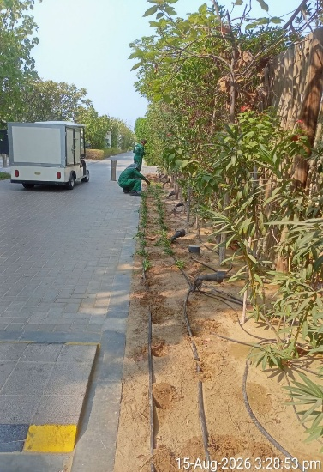 | 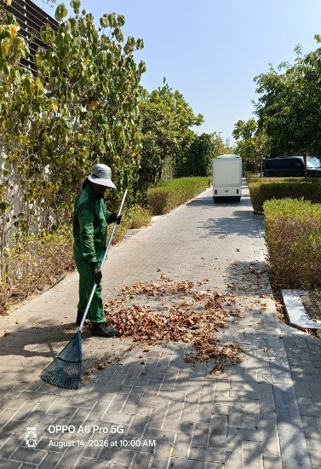 | 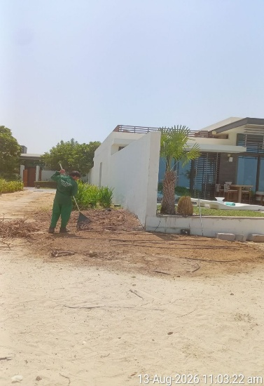 | 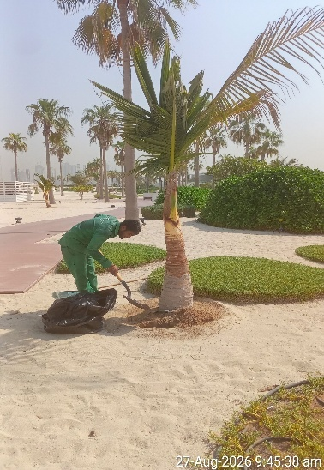
Replacement of groundcovers | Cleaning and Removal of Fallen Dry Leaves | Removal of existing scavolia plants | application of organic compost
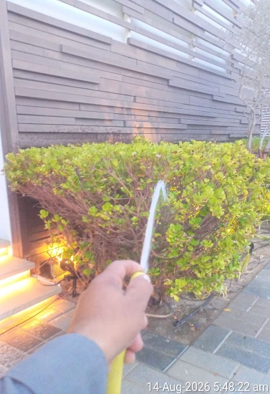 | 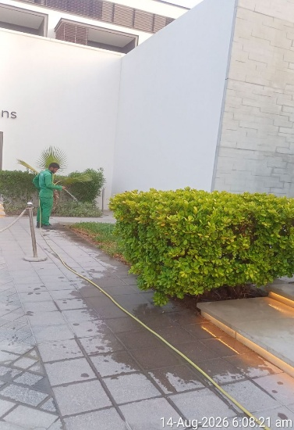 | 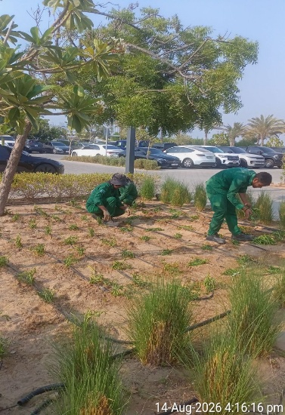 | 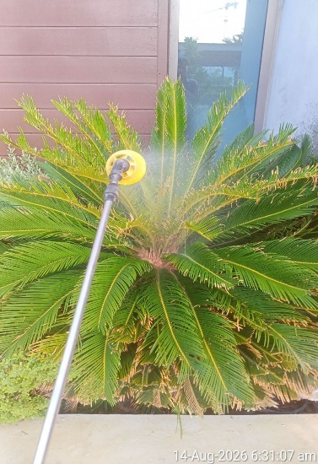
misting of the plants | Manual Watering | replacement of groundcovers | Application of Pesticides
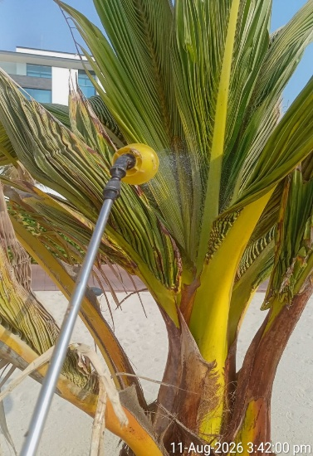 | 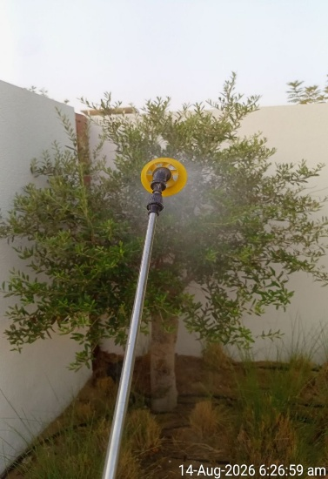 | 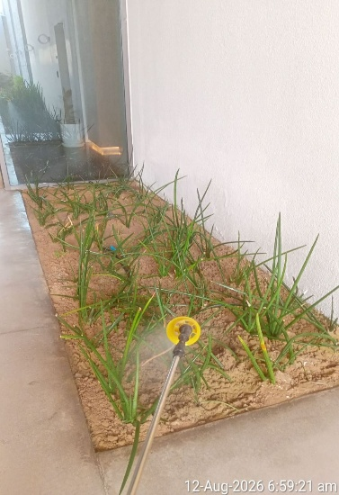 | 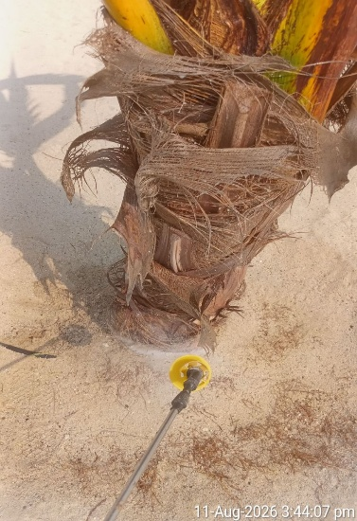
Application of fungicides | Application of Pesticides | Application of Pesticides | Application of fungicides

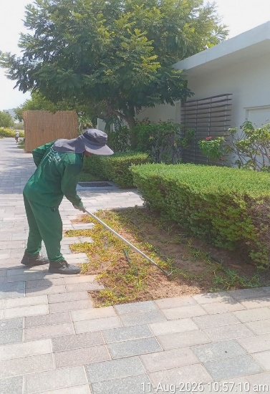 | 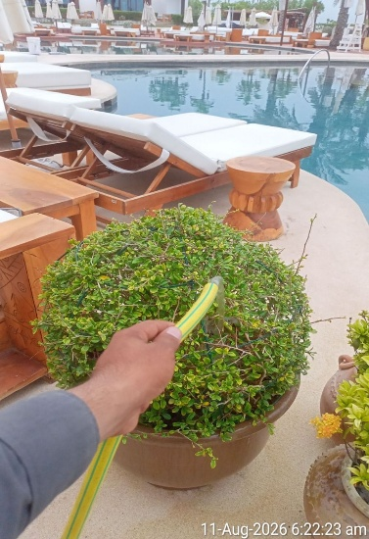 | 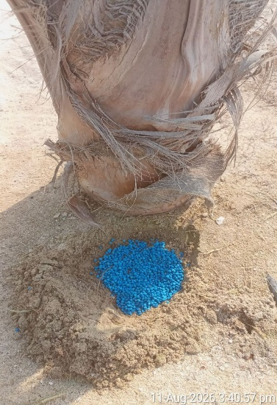 | 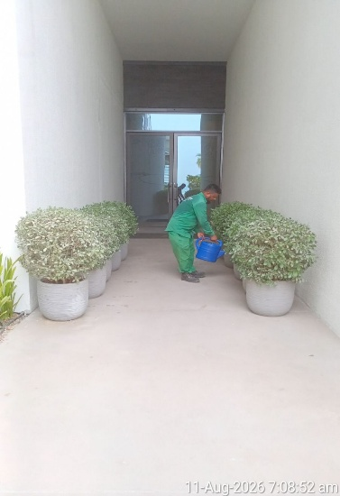
Soil Cultivation | Manual Watering | Application of NPK | Manual Watering
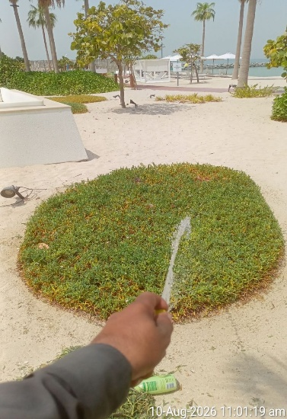 | 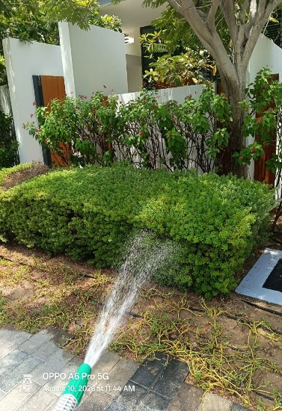 | 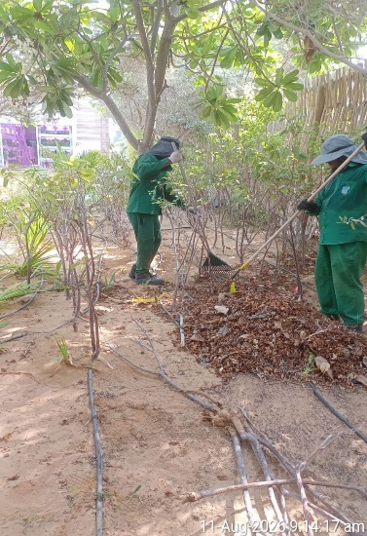 | 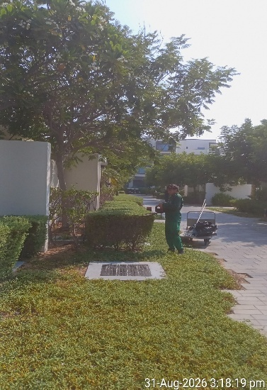
Manual Watering | misting of the plants | Removal of Dry Leaves | Trimming and shaping

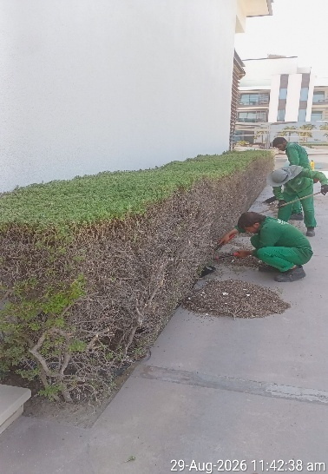 | 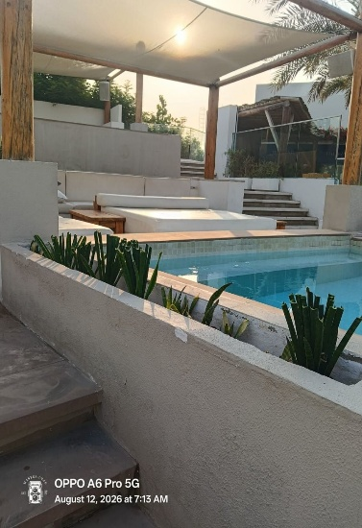 | 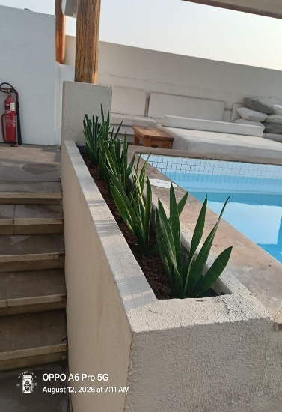 | 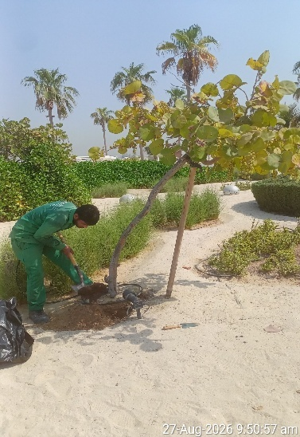
Removal of accumulated debris | After replacement | After replacement | Application of organic compost
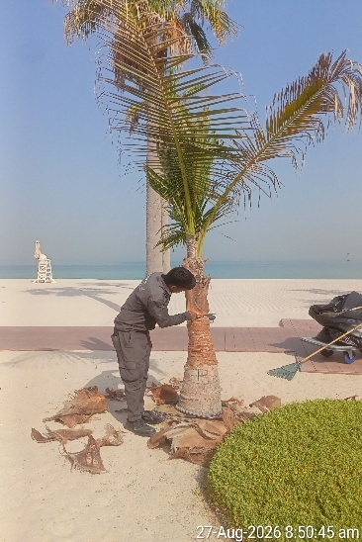 | 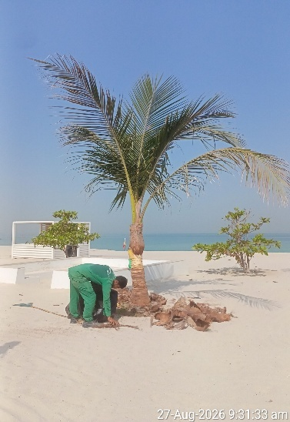 | 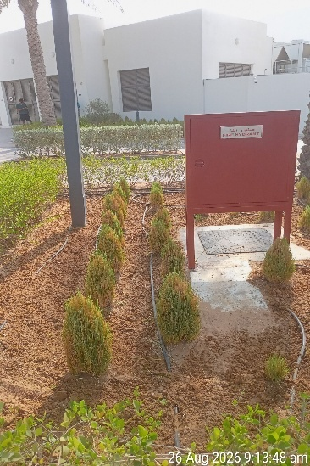 | 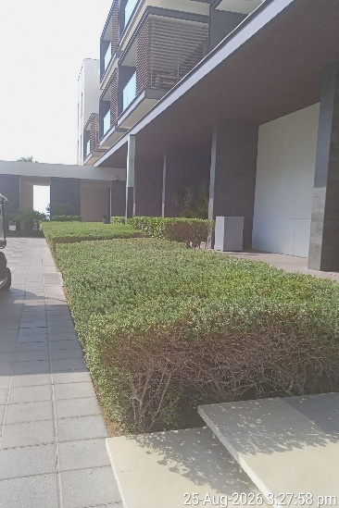
trunk cleaning of palms | trunk cleaning of palms | after soil cultivation | Trimming and shaping
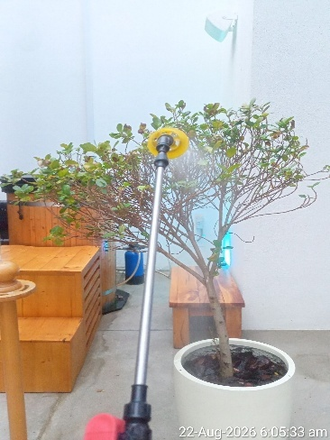 | 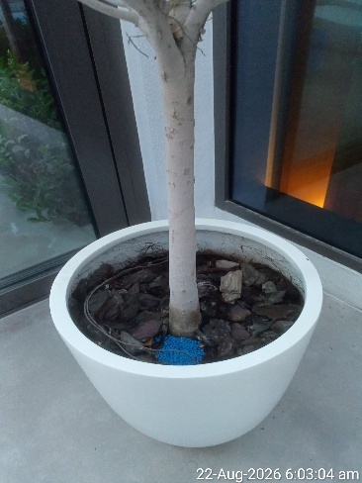 | 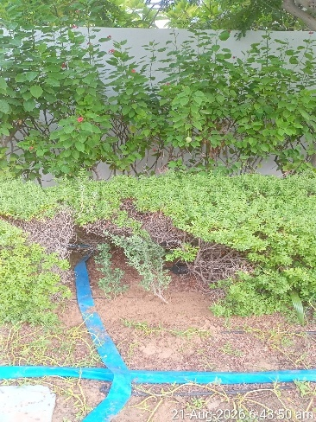 | 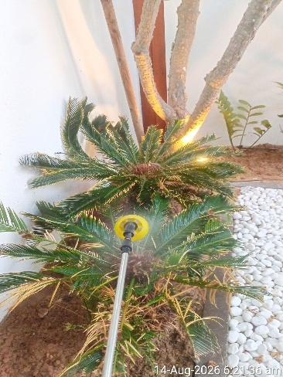
misting of the plants | application of NPK fertilzer | gap filling of dried plants | application of pesticides (Villas)
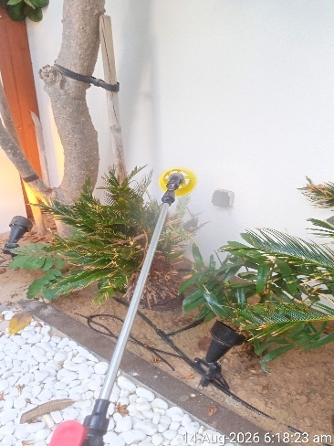 | 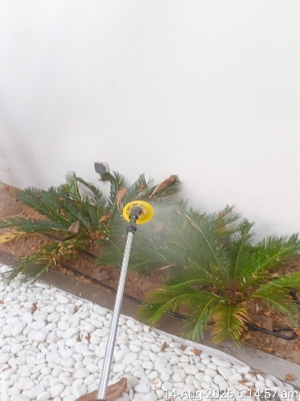 | 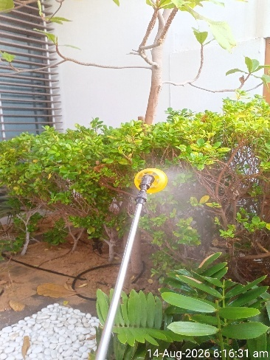 | 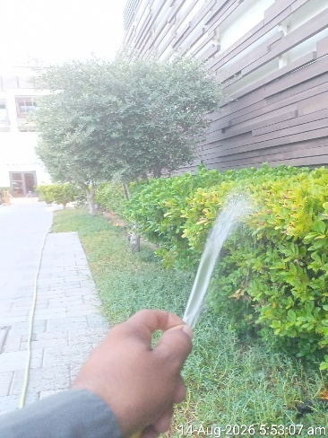
application of pesticides (Villas) | application of pesticides (Villas) | application of anti-transpirant spray | washing of the plants

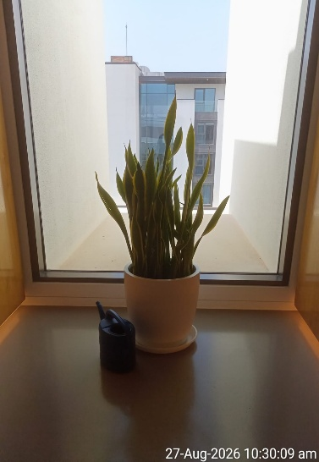 | 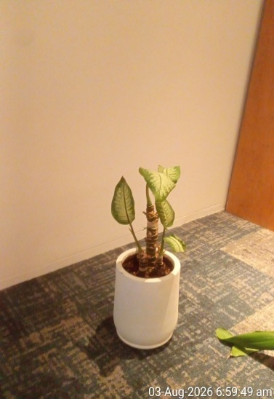 | 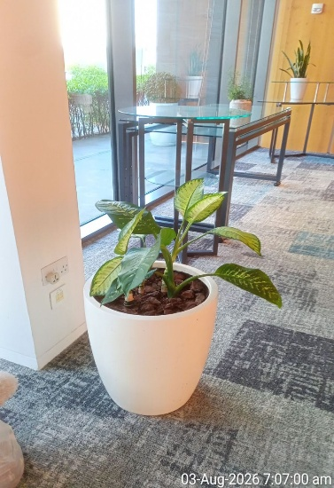 | 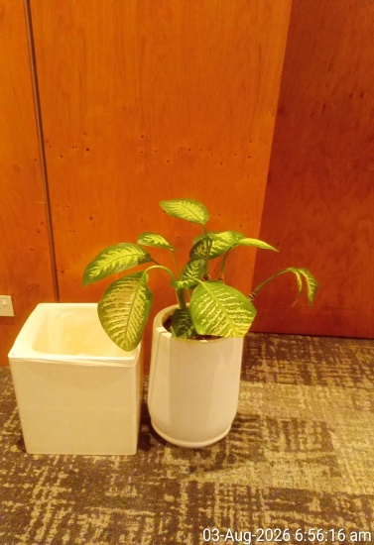
AFTER MANUAL WATERING | AFTER MANUAL WATERING | AFTER MANUAL WATERING | AFTER MANUAL WATERING
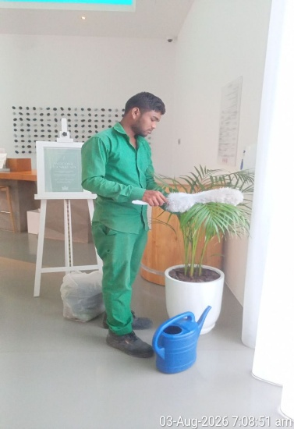 | 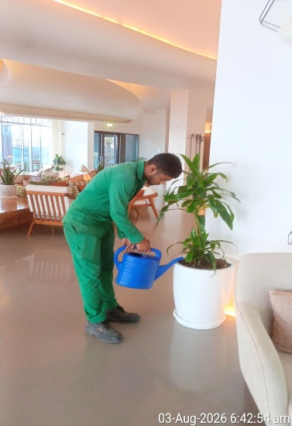 | 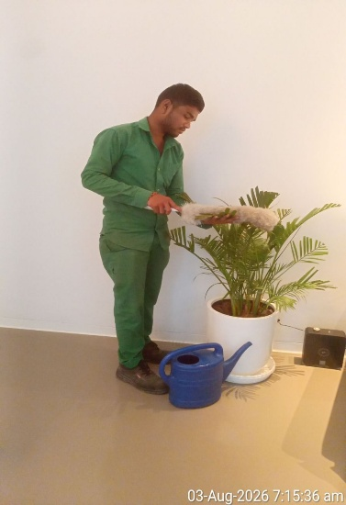 | 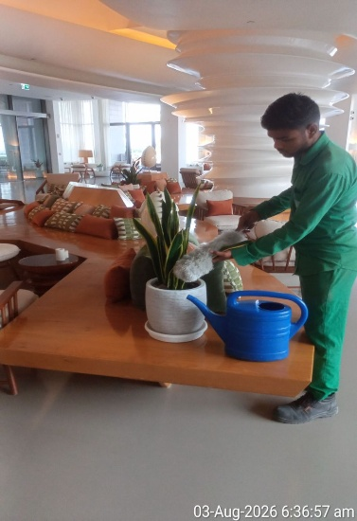
Dusting of Plants | Manual Watering | Dusting of Plants | Dusting of Plants

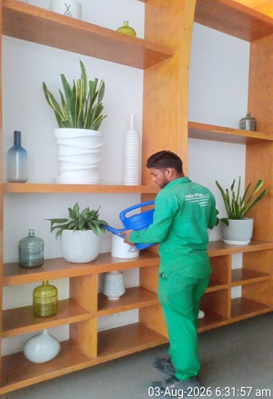 | 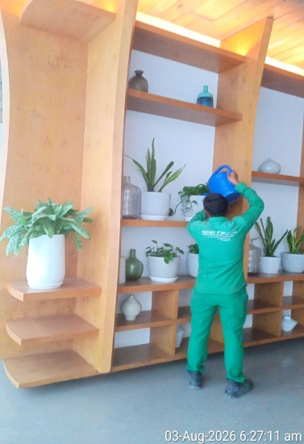 | 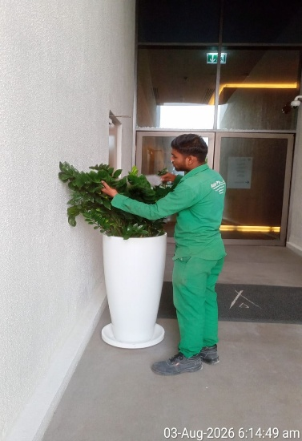 | 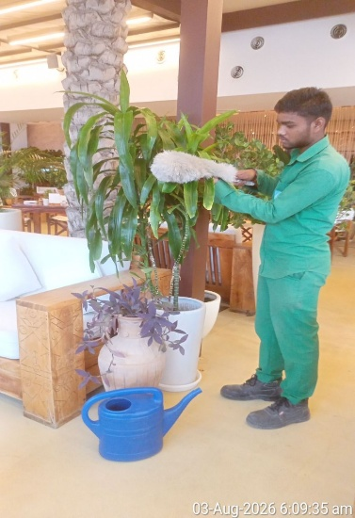
Manual Watering | Manual Watering | Dusting of Plants | Dusting of Plants
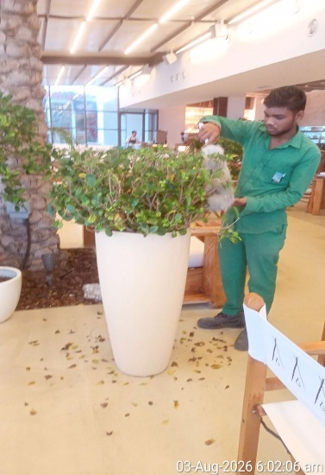 | 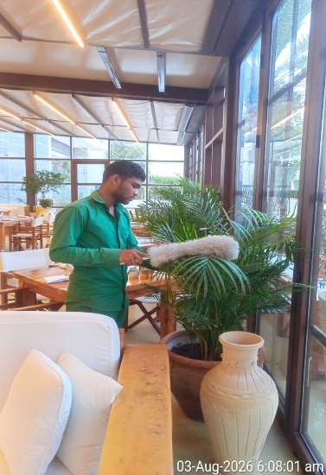 | 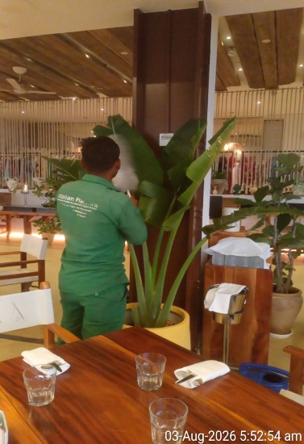 | 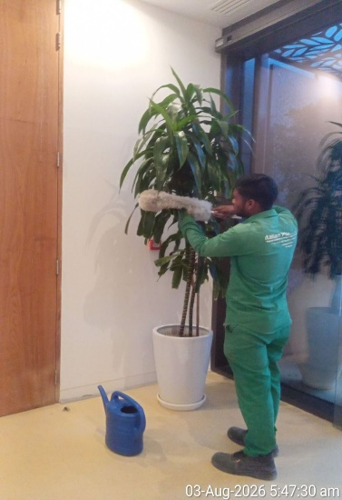
Dusting of Plants | Dusting of Plants | Dusting of Plants | Dusting of Plants
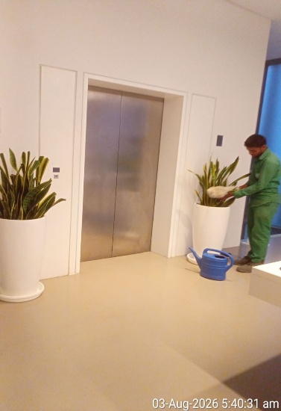 | 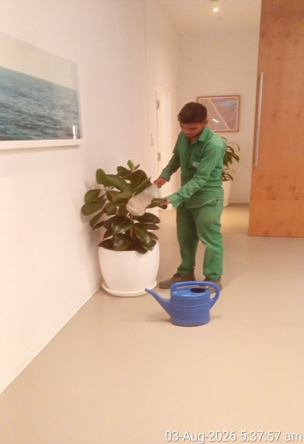 | 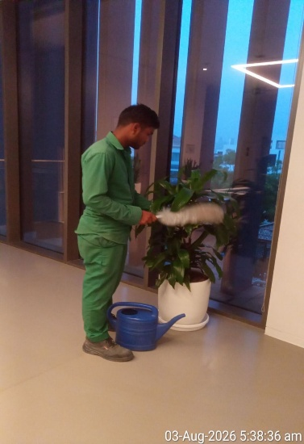 | 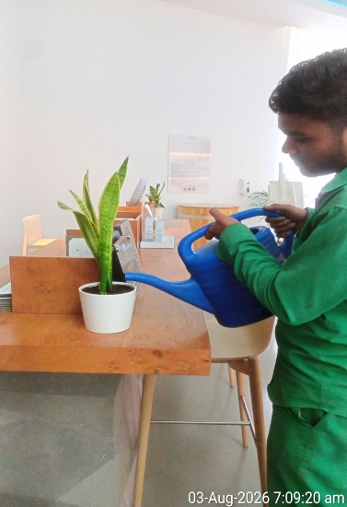
Dusting of Plants | Dusting of Plants | Dusting of Plants | manual watering

Agriculture Engineer | Basem Adel
Date | 05.09.2026

